NAME: RAJA RAYYAN AMEER
REG. NO.: 23-CP-25
SECTION: ALPHA
SUBJECT: DATABASE MANAGEMENT SYSTEM
DEPARTMENT: COMPUTER ENGINEERING
TEACHER: SIR SHAHID
OPEN END LAB PRACTICE – LAB 9
Problem Statement:
A beauty salon needs a database system to store and manage customers, employees, services, appointments, and payments efficiently. Manual record-keeping causes errors, missing information, and difficulty tracking operations. The OEL database is created to maintain accurate data, enforce relationships, and improve appointment, payment, and service management. It also supports updates, indexing, and cascading rules to ensure fast and reliable salon operations.
ERD (Entity–Relationship Diagram):
Table customers {
id int pk
full_name varchar
phone varchar
email varchar
address varchar
}
Table employees {
id int pk
full_name varchar
phone varchar
address varchar
role varchar
join_date date
pay int
}
Table services {
id int pk
service_name varchar
category varchar
description varchar
price int
duration_minutes int
tools_required varchar
gender_type varchar
service_level varchar
is_active boolean
}
Table appointments {
id int pk
customer_id int [not null]
employee_id int [not null]
service_id int [not null]
appointment_date datestatus varchar
}
Table payments {
id int pk
appointment_id int
amount int
payment_method varchar
payment_date datetime
payment_status varchar
}
Ref: appointments.customer_id > customers.id
Ref: appointments.employee_id > employees.id
Ref: appointments.service_id > services.id
Ref: payments.appointment_id > appointments.id
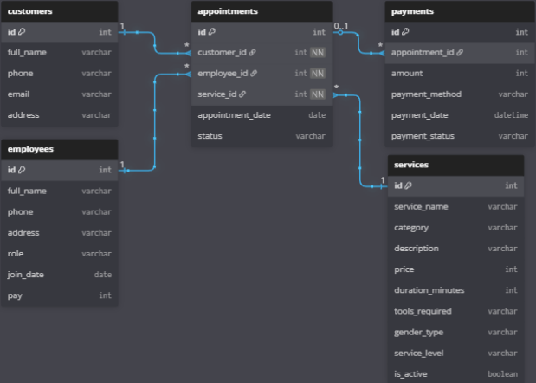
DDL (All CREATE TABLE Queries):
create database oel;
use oel;
create table customer(
customer_id int primary key,
full_name varchar(25),
phone varchar(11),
email varchar(20),
address varchar(255)
);
create table employees(
employee_id int primary key,
full_name varchar(25),
phone varchar(11),
address varchar(255),
role varchar(10),
join_date date ,
pay int
);
create table service(
service_id int primary key,
service_name varchar(10),category varchar(10),
description text,
price int ,
duration_minutes int,
tools_required varchar(15),
gender_type varchar(8),
service_level varchar(10),
is_active boolean
);
create table payment(
payment_id int primary key,
appointment_id int,
amount int,
payment_method varchar(10),
payment_date datetime,
payment_status varchar(10),
foreign key (appointment_id) references appointment(appointment_id)
);
create table appointment(
appointment_id int primary key,
customer_id int,
employee_id int,service_id int,
appointment_date date,
status varchar(10),
foreign key (customer_id) references customer(customer_id),
foreign key (employee_id) references employees(employee_id),
foreign key (service_id) references service(service_id)
);
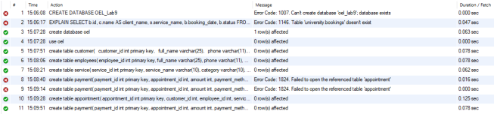
Sample INSERTS:
INSERT INTO customer (customer_id, full_name, phone, email, address) VALUES
(1, 'Ayesha Khan', '03001234567', 'ayesha@gmail.com', 'Street 12, Islamabad'),
(2, 'Sara Malik', '03119876543', 'sara@yahoo.com', 'Model Town, Lahore'),
(3, 'Fatima Noor', '03345556677', 'fatima@gmail.com', 'DHA, Karachi'),
(4, 'Hina Shah', '03005554433', 'hina@hotmail.com', 'Cantt, Rawalpindi'),
(5, 'Mahnoor Ali', '03451239876', 'mahnoor@gmail.com', 'Bahria Town, Lahore');
INSERT INTO employees (employee_id, full_name, phone, address, role, join_date, pay)
VALUES
(1, 'Sana Ahmed', '03003332211', 'Islamabad', 'Stylist', '2022-01-15', 40000),(2, 'Mehwish Zafar', '03112223344', 'Rawalpindi', 'Beautician', '2021-03-10', 35000),
(3, 'Nadia Salman', '03225556644', 'Lahore', 'Makeup', '2023-06-01', 45000),
(4, 'Zara Iqbal', '03446667788', 'Karachi', 'Hair', '2020-09-18', 38000),
(5, 'Alisha Rauf', '03005558822', 'Faisalabad', 'Nails', '2022-11-25', 30000);
INSERT INTO service (service_id, service_name, category, description, price,
duration_minutes, tools_required, gender_type, service_level, is_active) VALUES
(1, 'Facial', 'Skin', 'Deep cleansing and massage facial', 2500, 45, 'Basic Kit', 'Female', 'Premium',
1),
(2, 'Haircut', 'Hair', 'Professional haircut and styling', 1200, 30, 'Scissors', 'Both', 'Standard', 1),
(3, 'Manicure', 'Nails', 'Hand care with polish', 1500, 40, 'Nail Kit', 'Female', 'Standard', 1),
(4, 'Makeup', 'Makeup', 'Party makeup full service', 3500, 60, 'Makeup Kit', 'Female', 'Premium',
1),
(5, 'Massage', 'Body', 'Relaxing full body massage', 3000, 50, 'Oil Set', 'Both', 'Standard', 1);
INSERT INTO appointment (appointment_id, customer_id, employee_id, service_id,
appointment_date, status) VALUES
(1, 1, 1, 1, '2025-01-10', 'Done'),
(2, 2, 3, 4, '2025-01-12', 'Pending'),
(3, 3, 2, 2, '2025-01-15', 'Done'),
(4, 4, 5, 3, '2025-01-18', 'Cancelled'),
(5, 5, 4, 5, '2025-01-20', 'Pending');INSERT INTO payment (payment_id, appointment_id, amount, payment_method,
payment_date, payment_status) VALUES
(1, 1, 2500, 'Cash', '2025-01-10 14:30:00', 'Paid'),
(2, 2, 3500, 'Card', '2025-01-12 16:00:00', 'Unpaid'),
(3, 3, 1200, 'Cash', '2025-01-15 13:00:00', 'Paid'),
(4, 4, 1500, 'Cash', '2025-01-18 12:45:00', 'Refunded'),
(5, 5, 3000, 'Card', '2025-01-20 17:20:00', 'Unpaid');
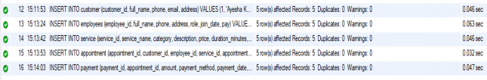
Queries:
-- query 1
update payment
set payment_status='paid'
where payment_id=2;
select * from payment;
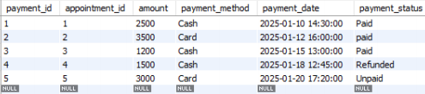
-- query 2
ALTER TABLE customer
ADD COLUMN membership_level VARCHAR(10);
-- query 3
UPDATE customer
SET membership_level = 'Gold'
WHERE customer_id IN (1, 3);
select * from customer;
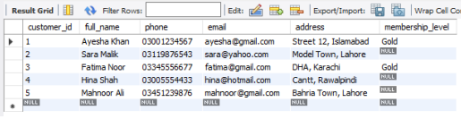
-- query 4
ALTER TABLE service RENAME TO service_detail;
-- query 5
SELECT e.full_name AS Employee,COUNT(a.appointment_id) AS Total_Appointments
FROM employees e
LEFT JOIN appointment a
ON e.employee_id = a.employee_id
GROUP BY e.employee_id;
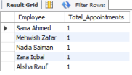
-- query 6
EXPLAIN
SELECT c.full_name AS customer,s.service_name AS service,e.full_name AS
employees,a.status,a.appointment_date
FROM appointment a
JOIN customer c ON a.customer_id = c.customer_id
JOIN service s ON a.service_id = s.service_id
JOIN employees e ON a.employee_id = e.employee_id;
-- query 7
ALTER TABLE appointment
DROP FOREIGN KEY appointment_ibfk_1;
ALTER TABLE appointment
ADD CONSTRAINT appointment_ibfk_1
FOREIGN KEY (customer_id) REFERENCES customer(customer_id)
ON DELETE CASCADE
ON UPDATE CASCADE;
ALTER TABLE appointment
DROP FOREIGN KEY appointment_ibfk_2; ALTER TABLE appointment
ADD CONSTRAINT appointment_ibfk_2
FOREIGN KEY (employee_id) REFERENCES employees(employee_id)
ON UPDATE CASCADE
ON DELETE CASCADE;
ALTER TABLE appointment
DROP FOREIGN KEY appointment_ibfk_3;
ALTER TABLE appointment
ADD CONSTRAINT appointment_ibfk_3
FOREIGN KEY (service_id) REFERENCES service_detail(service_id)
ON UPDATE CASCADE
ON DELETE CASCADE;
update customer
set customer_id=0
where customer_id=1;
select * from appointment;
update customer
set customer_id=1
where customer_id=0;
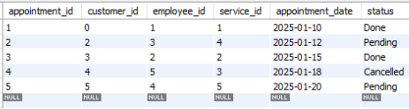
-- query 8
alter table customer add constraint unique(email);
Indexes:
CREATE INDEX idx_appointment_customer ON appointment(customer_id);
CREATE INDEX idx_appointment_employee ON appointment(employee_id);
CREATE INDEX idx_appointment_service ON appointment(service_id);
CREATE INDEX idx_appointment_date ON appointment(appointment_date);
CREATE INDEX idx_payment_status ON payment(payment_status);
CREATE INDEX idx_appointment_payment ON payment(payment_id);
CREATE INDEX idx_customer_customer ON customer(customer_id);
show index from appointment;
explain
SELECT * FROM customer WHERE customer_id = 3;
Before Indexing:
- The database had no indexes on appointment or payment tables except the primary keys.
- Searching data (like finding customer appointments, checking payment status, or filtering by date) required full table scans, meaning MySQL had to check every row.
- Queries such as:
- SELECT * FROM customer WHERE customer_id = 3;
- SELECT * FROM appointment WHERE customer_id = ?;
- SELECT * FROM payment WHERE payment_status = 'Paid';
took more time and used more CPU.
- JOIN operations across customer, employees, appointment, and service tables were slower because MySQL had to scan large sets of rows.
After Indexing:
- Queries now use indexes instead of full table scans.
- Searching by customer_id, employee_id, service_id, payment_status, or appointment_date becomes much faster.
- JOIN queries are optimized because the database can instantly locate matching rows using index values.
- EXPLAIN SELECT * FROM customer WHERE customer_id = 3;
will now show: type = ref or const instead of ALL
- key = idx_customer_customer, means the index is being used.
1-Slide Summary of Insights
- Designed a complete database to manage customers, employees, services, appointments, and payments.
- Ensures data accuracy using primary keys, foreign keys, cascades, and unique constraints.
- Supports efficient updates (payment status, membership levels), table renaming, and schema modifications.
- Indexing improves search speed for appointments, payments, and customer records.
- Queries provide insights such as employee workload, appointment details, and service usage.
- Overall, OEL database streamlines salon operations, reduces errors, and enables fast, organized data handling.
THE END

